**1. Abstract**

* Security management system is global security is an independent security company of highly trained professional person who collectively have many years of security experience.
* We offer a discrete and confidential service structured to supply the fall spectrum of personal and corporate security requirements worldwide.
* By maintaining constant contact with specialist military and civilian organizations world-wide. Our Personal have up to data knowledge of new developments.
* Furthermore our skills are supported by an extensive database of oriticaland practical database information thus planning us in the unique position of being able to offer the most cost-effective package in the fields of security management and implementation.

**Current System:**

- In this system we have currently covered many of the processes online, but there are some technicalities we would like to overcome in the future changes, like adding maps to directly allocate the positions and online payment section.

**Existing System:**

- The existing system is having very unique amount of access provides that ease up the work like adding forms for both customer and jobseeker and the online portfolio of the whole company.

**Modules:**

* Officers:-deal with the client for the even management or security management.
* Supervisor:-manage the guards which are on a duty.
* Head guard:-Head guard is a senior guard who acts as a supervisor in the absence of later.
* Guard : - maintains the position given and mainly pasted at the gates of area.

**Purpose:**

* The purpose of this document is to describe the security management.
* This document contains the functional and non-functional requirements of the project and it also contains the guidelines for system engineers and designers to start working the project.

**Scope:**

Security Management System is basically updating the manual security system into internet based application. So that the users or customer can know the details of our security and employees and events.

**2.Requirements**

* Employees:-The List of employees working in the firm with all the details.
* Types Of Employees :-
* Guards
* Bouncers
* Promoters
* Gunman’s
* Bodyguards

**Details of Employees:**

* Displays the details of our employees currently working in the firm.
* The height of the Bouncers, followed by weight, Complexion, locality and personal details.

**Functional Requirement:**

* Guarding Services:-
* We have multi layered organizational structure with each and every level has clear cut responsibility and well defined roles.
* They are:
* Officers
* Supervisors
* Head guards
* Guards
* Armed-guards
* Ladies-guards
* Security Officers:-
* Most of the security officers are from Indian Army, and are well experienced in the matter of security by virtual of the length of service and the various position held by then.
* Supervisors are skilled persons well trained in the art of security. Briefly their function is to manage the guards which are on duty.
* Head guards is a senior guard who acts as a supervisor in the absence of the later.
* Our Security Management Service is a “One-Stop-Shop” for all kinds of facility services, ranging from general housekeeping and pantry services to office support staff.

**Non-Functional Requirement:**

* Event Services:-
* Any type of parties which includes.
* Marriage Function
* Disco Party
* Inaugurations of some new firms or any new buildings.
* Celebrities and film stars protection.
* Protective Security Which Include:-
* Office Security
* Public Appearance
* Travel Abroad
* Hotel Security
* Residential Security
* ATM Security
* Fire Services
* Corporate Security Includes:-
* Business Intelligence
* Overseas Security Terms
* Corporate Surveillance

**Specific Requirement:**

**-**The section contains all of the functional and quality

requirements of the system.

**-**It gives a detailed description of the system and all its

Features.

**3.User - Interface**

**-**A first time user of the website should see the log-in page when he/she opens the website.

**-** If the user has not registered he/she should be able to do that on the login page.

**-** If the user is not a first time user than he/she has no need and not see the registered or login page.

**-** After the login page the user might want to make an appointment with the company for the event to be organized.

**-** So the page of the work order or inquiry will appear.

**-**Now as the details are filled by the user and then after clicking the submit button the user will receive an automated email by system that he will be contacted soon. So after the authentication of the details entered by user the event of the user is organized and contacted by the company via E-mail or phone number.

**4. Data Flow Diagram**

**1. DFD Level 0(Context Level):-**

Customer

Supervisor

Assign Job

Employee

Admin

Job Seeker

Management

Apply For Job

Approve Job

Job Details

Approve and Send Staff Details

Schedule

Staff Details Approve

Other Works

Apply Event

**2. DFD Level 1:-**

Event

Management

Event

Customer

Apply For Event

Employee

Staff

Details

Employee

Staff Details

Supervisor

Approve Event

Event

Event Details

Employee

Management

Schedule Manage

**1**

**2**

Employee

Event Details

Job Details

Job Details for Employee

Service

Management

**3**

Admin

Manage

Review Performance

Overall Review

**3. DFD Level 2:-**

* **Level 1.1:-**



* **Level 2.1:-**

Registration

Verification

Conformation

Employee-Details

Types of job

Job Seeker

Job Seeker

Conformation for Job

Supervisor

Admin

Employee

Types of Job

Employee

Role of Employee

Decide the role of Employee

**2.1**

**2.2**

**2.3**

**2.4**

**2.5**

Send Request for Job

Send Response

Get Request

Conform the Request

Send Details

* **Level 3.1:-**

Types of Service

Role Assignment

Event Services

Event

Supervisor

Employee

Assign Services Details

Assign Role

Provide Event Details

Types of Job

Role Wise Responsibilities

Send Details of Event

**3.1**

**3.2**

**3.3**

**5. E-R Diagram**



**6. Data Dictionary Diagram**

* Employee:-

|  |  |  |  |  |
| --- | --- | --- | --- | --- |
|  | **Field Name** | **Data Type** | **Length** | **Not Null** |
| * | E-ID | Number | 5 | ✓ |
|  | Name | Text | 15 | ✓ |
|  | Age | Number | 3 | ✓ |
|  | Height | Number | 3 | ✓ |
|  | Width | Number | 3 | ✓ |
|  | Date Of Birth | Date And Time | - | ✓ |
|  | Email Id | Hyperlink | 25 | ✓ |
|  | Contact No | Number | 15 | ✓ |
|  | Address | Text | 40 | ✓ |

* **Job Seeker:**

|  |  |  |  |  |
| --- | --- | --- | --- | --- |
|  | **Field Name** | **Data Type** | **Length** | **Not Null** |
| * | Name | Text | 15 | ✓ |
|  | Age | Number | 3 | ✓ |
|  | Height | Number | 3 | ✓ |
|  | Width | Number | 3 | ✓ |
|  | Date Of Birth | Date And Time | - | ✓ |
|  | Email Id | Hyperlink | 25 | ✓ |
|  | Contact No | Number | 15 | ✓ |
|  | Address | Text | 40 | ✓ |
|  | Status | Text | 10 | ✓ |

* **Customer:**

|  |  |  |  |  |
| --- | --- | --- | --- | --- |
|  | **Field Name** | **Data Type** | **Length** | **Not Null** |
| * | C-ID | Number | 5 | ✓ |
|  | Name | Text | 15 | ✓ |
|  | Application | Text | 15 | ✓ |
|  | Address | Text | 40 | ✓ |
|  | Contact No | Number | 15 | ✓ |
|  | Email Id | Hyperlink | 25 | ✓ |
|  | Executive Requirement | Number | 3 | ✓ |
|  | Time Duration | Hours | 5 | ✓ |

* **Venue:**

|  |  |  |  |  |
| --- | --- | --- | --- | --- |
|  | **Field Name** | **Data Type** | **Length** | **Not Null** |
| * | Venue ID | Number | 5 | ✓ |
|  | Venues | Text | 15 | ✓ |
|  | Address | Text | 40 | ✓ |
|  | Map | Image | - | ✓ |
|  | Reporting Time | Hours | 5 | ✓ |

* **Event:**

|  |  |  |  |  |
| --- | --- | --- | --- | --- |
|  | **Field Name** | **Data Type** | **Length** | **Not Null** |
| * | Event ID | Number | 5 | ✓ |
|  | Type Of Event | Text | 15 | ✓ |
|  | Name Of Event | Text | 15 | ✓ |
|  | Duration | Hours | 5 | ✓ |

* **Customer-Event:-**

|  |  |  |  |  |  |
| --- | --- | --- | --- | --- | --- |
|  | **Field Name** | **Data Type** | **Length** | **Not Null** | **Key** |
| * | Customer + Event ID | Number | 10 | ✓ | Primary |
|  | Customer ID | Number | 5 | ✓ | Foreign |
|  | Event ID | Number | 5 | ✓ | Foreign |
|  | Venue ID | Number | 5 | ✓ | Foreign |
|  | Date Of Event | Date/Time | - | ✓ | - |

* **Customer-Employee:-**

|  |  |  |  |  |  |
| --- | --- | --- | --- | --- | --- |
|  | **Field Name** | **Data Type** | **Length** | **Not Null** | **Key** |
| * | Customer + Employee ID | Number | 10 | ✓ | Foreign |
|  | Employee ID(E-ID) | Number | 5 | ✓ | Foreign |

* **Types of Job:-**

|  |  |  |  |  |
| --- | --- | --- | --- | --- |
|  | **Field Name** | **Data Type** | **Length** | **Not Null** |
| * | Job ID | Number | 10 | ✓ |
|  | Name | Text | 10 | ✓ |
|  | Role | Text | 10 | ✓ |

**7.Snapshot**

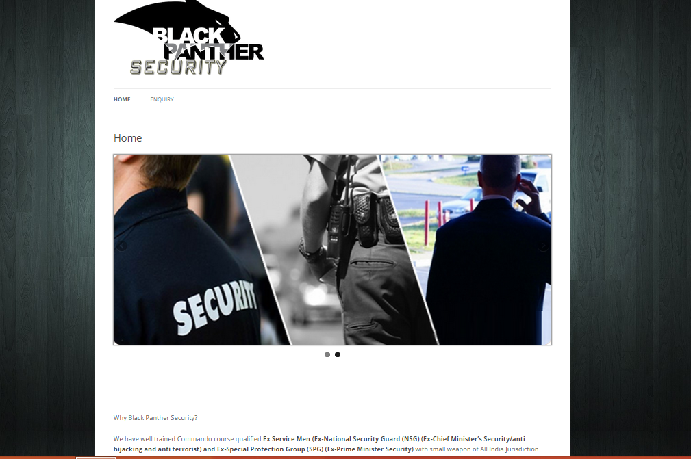

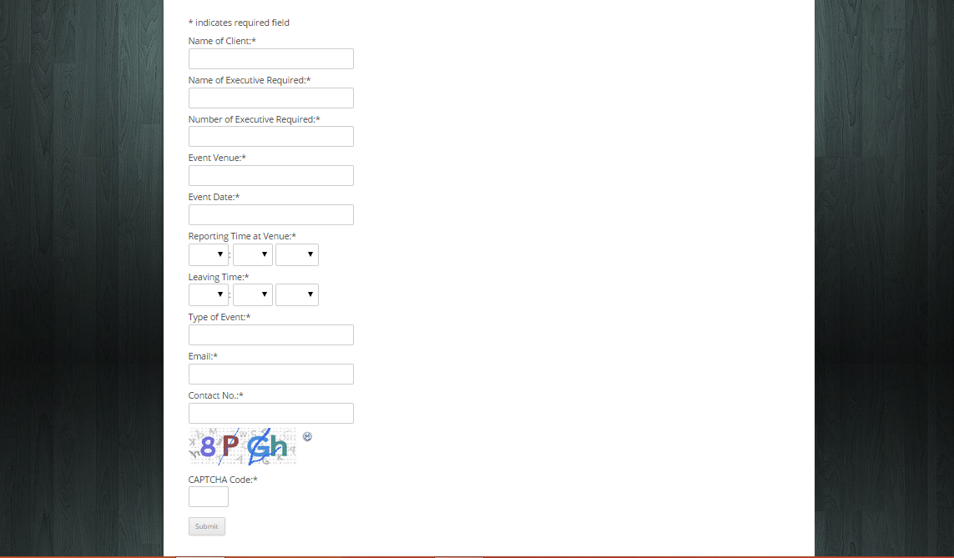

**8. Bibliography**

1. [www.redfoxprotection.in](http://www.redfoxprotection.in)
2. [www.adarshsecurity.in](http://www.adarshsecurity.in)
3. [www.kavachsecurity.in](http://www.kavachsecurity.in)